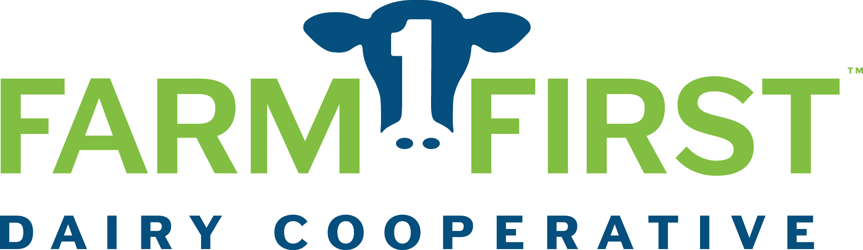

2021 Scholarship Application Requirements

Only completed applications are considered for scholarships. Completed applications include:
- The three-page scholarship form, completely filled out.
- A copy of your most current transcripts/grades (either high school or college).
- Two letters of recommendation (Letters should come from a mentor, advisor, teacher, coach or employer that is not a family member.)
- Confirmation of acceptance to a college, university, technical college, short course (if currently in high school or not yet attending post-secondary school). This may be a copy of your acceptance letter or a copy of an email confirming your enrollment.
- Digital photo (head and shoulders photo) for publicity purposes. Please email your digital photo to info@farmfirstcoop.com if submitting your application as a printed copy.

Eligibility
- Applicant must be a son or daughter of a FarmFirst Dairy Cooperative member. Extended family members will not be eligible for this scholarship.
- Applicants must be currently enrolled or accepted into an accredited college, university, technical college or short course. High school students must include a copy of their acceptance letter, and students currently enrolled in college must submit their most recent semester grades.
- Applicants will be selected on leadership, scholastic achievement (GPA of 2.5 or above on a 4.0 scale), extracurricular activities and essay responses.
- Applicants may only receive this scholarship once.

An independent committee selected by the FarmFirst Dairy Cooperative Board of Directors will make the final decision on scholarships to be awarded.

Application Deadline: Applications must be received by March 31, 2021.

Completed applications may be submitted via:

Online: www.FarmFirstDairyCooperative.com
Select Scholarships from ‘Member Services’ from the top menu.
Click on the online form to fill out the application.

Mail: FarmFirst Dairy Cooperative
c/o Scholarships
P.O. Box 14380
Madison, WI 53708-0380

E-mail: info@farmfirstcoop.com

Fax: 608-244-3643

SCHOLARSHIP APPLICATION FORM
GENERAL:

Name: ___________________________________ Date of Birth: ____________________

Home Address: ____________________________________________________________

City: ___________________ State: ________ Zip: ____________

Home phone: ______________________ Cell phone: ________________

E-mail (personal preferred, not high school email): ________________________________________________

Name of Parent(s) or Legal Guardian (if applicable):___________________________________________

Email of Parent(s) or Legal Guardian (if applicable):___________________________________________

Plant Name Parents Ship To: _______________________________________ Patron No. ____________

County of Residence: _____________________________

Home Town Newspaper – Name & Address ________________________________
(For Publicity Purposes) ________________________________
________________________________
Newspaper Website: _____________________

Newspaper Email: _______________________

SELECT ONE:
_____ Yes, I am currently attending High School.
High School Attending ______________________________ Expected Graduation Date: _________________
High School GPA: _______
Name of Post-Secondary School Attending: _________________________________________________
Major: _________________________________________________

_____ Yes, I am currently attending Post-Secondary School.
Name of University, College, Tech School ___________________________
Major: __________________________________________ # of Semesters Completed: ________
Minor: __________________________________________
GPA: __________
High School Attended: _________________________________________ Graduated On: ____________
High School GPA: _________
PLEASE ANSWER/COMPLETE THE FOLLOWING: (You may use a separate piece of paper.)

Involvement in Membership Organizations (including Breed Associations, etc...)
Organization Name: | Years as a member: | Offices Held:

Summarize work experience (on and off the farm – include duties performed): __________________________
__________________________________________________________________________________________________________________________________________________________________________________________________________________________________________________________________________________________________________________________________________________________________________________________________________________________________________________________________________________________________________________________________________________________________________________________________________________________________________________________________________________________________________________________________________________________________________________________________________________________________________

Note honors and awards received (4-H, FFA, Scholastic, Athletic, Community, etc): ______________________
__________________________________________________________________________________________________________________________________________________________________________________________________________________________________________________________________________________________________________________________________________________________________________________________________________________________________________________________________________________________________________________________________________________________________________________________________________________________________________________________________________________________________________________________________________________________________________________________________________________________________________

List other activities in school or the community in which you participated in: ____________________________
______________________________________________________________________________________________________________________________________________________________________________________________________________________________________________________________________________________________________________________________________________________________________________________________________________________________________________________________________________________________________________________________________________________________________________________________________________________________________________________
____________________________________________________________________________________________________________________________________________________________________________________
ESSAY Please limit your response to 500 words or less. Please use a separate page for submitting your essay responses. Be sure to answer each part of the question.

QUESTION: 2020, due to COVID-19, has been a challenging year for everyone, especially dairy farmers. No one could fully prepare for the roller coaster that milk and dairy product prices experienced from March through November. However, there were some good things that came from the pandemic and a few lessons that dairy farmers should have learned and could use to prepare for the future.

What was the immediate impact on dairy farmers?

What actions were taken that played a major role in providing meaningful support to dairy farmers and industry? Was it enough and/or should something else be done?

Identify some of the good things related to dairy that have come from the pandemic?

What can dairy farmers do to better protect their business should there be another pandemic or volatile milk and dairy prices?

If chosen as a scholarship recipient, I hereby authorize FarmFirst Dairy Cooperative to use my photo for public relation purposes:

Applicant Signature: ______________________________________________ Date: ___________________
Parent/Guardian Signature: _________________________________________

OFFICE USE ONLY:
____ Application Form ____ TWO Recommendation Letters
____ Transcript/Grades ____ Post-Secondary Acceptance Letter (if applicable)
____ Photo ____ Postmarked by March 31, 2021

This application must be submitted or postmarked by March 31, 2021 in order to be accepted.

